ALL ABOUT ME

I EAT:
Whiskas, Dine, Snappy Tom, Chicken, Rabbit, Fish (Remove all bone please) and chunks of raw meat at least once a week. On occasion please mix an egg yolk or vegetable oil with my tinned food. I also like grated cheese, it helps bind my bowels. A small handful of dry food such as SUPERCOAT for cats in the morning is sufficient; too much dry food can cause kidney problems. Currently, I am getting a mixture of Supercoat and Whiskas Professional formula on a 2 to 1 ratio.
Please do not give me cows’ milk unless I am constipated as it may make me very runny and messy. I may be allergic to cows’ milk, goats milk may be OK. Always ensure that I have plenty of fresh water in a ceramic bowl not a plastic one as they give the water a bad taste. I am currently having two meals a day. Because of the differences between dog and cat foods, I will suffer malnutrition and possible die if fed exclusively on dog food.

I PLAY WITH:
Everything I should not; ping-pong balls, pieces of string, cardboard boxes, paper bags, tape measures, toilet rolls, dressing gown cords, Dad's smelly socks, Mum’s toes and anything else that I can find. Your toes and fingers are great toys especially under the blankets at night.

I NEED:
A nice warm bed, preferably under the blankets next to mum and dad, but you may have other ideas. A basket with a sheepskin or blanket is needed. Please keep me inside as I have never been allowed out of the house and have no idea of how to behave outside. You may need to lock me in the laundry for the first few days when you go to bed otherwise I will come and rumble sweet nothings in your ear. For my litter tray, I currently use a mixture of Rabbit pellets and Breeders Choice in a 1 to 2 ratio. Please remove any solids from my tray daily. The remaining material can then be placed in your compost heap.
While I am growing, a vitamin supplement may be necessary as the tinned food etc. is not a balanced diet and some calcium is required for strong bones and teeth. Please consult my breeder or your vet as to the correct amounts. Your vet will have supplies of the supplements at his surgery.
My ears need to be cleaned on a regular basis, especially if I have been playing in the dirt and dust. Use a piece of dampened cotton wool soaked in mild soapy water. Squeeze the cotton wool as dry as possible and remove any dirt, grease or wax that you can see. Please do not use a cotton bud on a stick as you can damage my ears this way. If I still rub and scratch at the inside of my ears please consult your vet.
Please clip my claws at least once every two weeks. This will prevent them from becoming too sharp and scratching you. Only take 1 or 2 millimeters off. Do not cut into the pink area of my claws as this will cause bleeding and may lead to infection. If you are not sure please ask my breeder or your veterinarian.

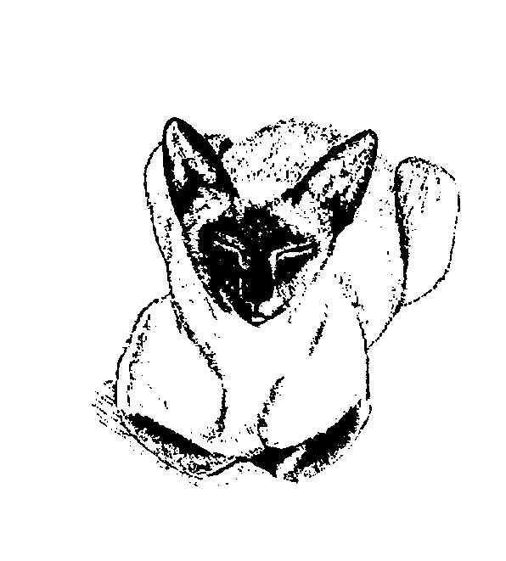
DESEXING
I will have been desexed before you take me to my new home. Please do not believe that old wives tale about female kittens needing a litter before being desexed. Each litter that a cat has reduces her life span by 1 to 2 years.

I PROMISE:
If you do all this for me, I promise to love you and cause multitudes of problems, scatter wool and paper all over the house. Climb up your trousers (even if you are not wearing any) and sleep next to you ear and rumble very happily. Please keep in touch with my other mum as she is very interested to hear how I develop. Photographs are always welcome.

